CYBERGRAPH: A GRAPH RAG-POWERED CYBER THREAT
INTELLIGENCE PLATFORM

A PROJECT REPORT
(Phase I)
Submitted by
HARI KRISHNAN S 23AD048
NAVEEN S 23AD086

in partial fulfillment for the award of the degree of
BACHELOR OF TECHNOLOGY
in
DEPARTMENT OF ARTIFICIAL INTELLIGENCE AND DATA SCIENCE

[ CHENNAI INSTITUTE OF TECHNOLOGY — INSTITUTE LOGO ]

CHENNAI INSTITUTE OF TECHNOLOGY
(AUTONOMOUS)
(Affiliated to Anna University, Chennai & Recognized by AICTE New Delhi)
Chennai-600 069
AUGUST-2026

Vision of the Institute:
To be an eminent centre for Academia, Industry and Research by imparting knowledge, relevant practices and inculcating human values to address global challenges through novelty and sustainability.

Mission of the Institute:
IM1. To create next generation leader by effective teaching learning methodologies and instill scientific spark in them to meet the global challenges.
IM2. To transform lives through deployment of emerging technology, novelty and sustainability.
IM3. To inculcate human values and ethical principles to cater the societal needs.
IM4. To contributes towards the research ecosystem by providing a suitable, effective platform for interaction between industry, academia and R&D establishments.
IM5. To nurture incubation centres enabling structured entrepreneurship and start-ups.

Vision of the Department:
To Achieve excellent standards of quality-education by using the latest tools, nurturing collaborative culture and disseminating customer oriented innovations to relevant areas of academia and industry towards serving the greater cause of society.

Mission of the Department:
IM1. To develop professionals who are skilled in the area of Artificial Intelligence and Data Science.
IM2. To impart quality and value based education and contribute towards the innovation of computing, expert system, Data Science to raise satisfaction level of all stakeholders.
IM3. Our effort is to apply new advancements in high performance computing hardware and software.

CHENNAI INSTITUTE OF TECHNOLOGY
(AUTONOMOUS)
(Affiliated to Anna University, Chennai & Recognized by AICTE New Delhi)
Chennai-600 069
BONAFIDE CERTIFICATE
Certified that this project report (Phase – I) “CYBERGRAPH: A GRAPH RAG-POWERED CYBER THREAT INTELLIGENCE PLATFORM” is the bonafide work of HARI KRISHNAN S (23AD048) and NAVEEN S (23AD086) who carried out the project work under my supervision.

Signature  Ms. Shanmuga Sundari M.E  HEAD OF THE DEPARTMENT  Assistant Professor  Department of Artificial Intelligence  and Data Science,  Chennai Institute of Technology,  Kundrathur, Chennai-600069. | Signature  Dr.K.Ramanan, M.Tech, Ph.D  PROJECT SUPERVISOR  Associate Professor,  Department of Artificial Intelligence  and Data Science,  Chennai Institute of Technology,  Kundrathur, Chennai-600069.

Certified that the above students have attended a viva voce during the exam held on………………....
INTERNAL EXAMINER | EXTERNAL EXAMINER

ACKNOWLEDGEMENT
We express our gratitude to our Chairman Shri.P.SRIRAM and all trust members of Chennai Institute of Technology for providing the facility and opportunity to do this project as a part of our undergraduate course.
We are grateful to our Principal Dr.A.RAMESH M.E, Ph.D, for providing us the facility and encouragement during the course of our work.
We would like to extend our thanks to our Dean, Dr.V.SRINIVASA RAO M.Tech, PhD, for providing their valuable suggestions throughout this project.
We sincerely thank our Head of the Department, Ms. Shanmuga Sundari, Assistant Professor, Department of Artificial Intelligence & Data Science, for having provided us with valuable guidance, resources and timely suggestions throughout our work.
We sincerely thank our Project Supervisor, Dr.K.RAMANAN, M.Tech, Ph.D, Associate Professor, Department of Artificial Intelligence & Data Science, for having provided us with valuable guidance, resources and timely suggestions throughout our work.
We would like to extend our thanks to our Project Coordinator, Dr.K.RAMANAN M.Tech, Ph.D, Associate Professor, Department of Artificial Intelligence & Data Science, for his valuable suggestions throughout this project.
We wish to extend our sincere thanks to all the Faculty Members of the Department of Artificial Intelligence & Data Science, for their valuable suggestions and their kind cooperation for the successful completion of our project.
We wish to acknowledge the help received from the Lab Instructors of the Department of Artificial Intelligence & Data Science, and others for providing valuable suggestions and for the successful completion of the project.

ABSTRACT
Modern Security Operations Centres (SOCs) are drowning in threat data that refuses to connect itself: CVE advisories from NVD, technique catalogues from MITRE ATT&CK, indicator feeds from open threat-sharing communities, and weakness taxonomies such as CWE and CAPEC each live in their own silo, in their own format, updated on their own schedule. An analyst who wants to answer a realistic question — “Which attack techniques does APT29 use that exploit unpatched Windows servers, and are any of those CVEs in the CISA Known Exploited Vulnerabilities catalogue?” — must manually join five or more of these sources by hand, a process that is slow, error-prone, and impossible to repeat consistently across a growing alert queue. Conventional document-based Retrieval-Augmented Generation (RAG), which retrieves loosely related text chunks by vector similarity, does not solve this problem either, because it has no notion of the structured, multi-hop relationships — actor uses technique, technique is realised by malware, malware exploits CVE, CVE affects product — that actually define how a cyber attack unfolds. This project proposes the CyberGraph Intelligence Platform, a Graph Retrieval-Augmented Generation (Graph RAG) system that models the cybersecurity domain as a single, richly interconnected knowledge graph in Neo4j, built entirely from free and publicly available intelligence sources: NVD/NIST (CVEs and CVSS scores), MITRE ATT&CK (tactics, techniques and threat-actor groups), CAPEC and CWE (attack patterns and root-cause weaknesses), AlienVault OTX (indicators of compromise), the CISA Known Exploited Vulnerabilities catalogue, and the Exploit Prediction Scoring System (EPSS). The graph is exposed to a Large Language Model through a LangChain-orchestrated Graph RAG engine that combines two complementary retrieval modes — LLM-generated Cypher traversal for structured, relationship-based questions, and Neo4j vector-index similarity search for fuzzy, semantic ones — merging both before final answer synthesis, so that a single natural-language query can traverse actor, technique, malware, CVE and affected-product nodes in one reasoning chain, exactly the way a human analyst pivots through intelligence. On top of this shared graph, the platform delivers ten modular intelligence capabilities spanning threat-actor profiling, CVE enrichment and a composite ThreatPriority Score, attack-path and kill-chain mapping, IOC correlation and pivoting, a hypothesis-driven threat-hunting workbench, sector and asset risk scoring, an incident-response assistant that generates graph-grounded playbooks, and an executive intelligence dashboard, all served through a FastAPI REST layer and a Streamlit analyst interface. By replacing manual, single-hop lookups with graph-native, relationship-aware reasoning, the proposed system aims to shorten investigation time, surface risk that flat correlation would miss, and give analysts, threat hunters and CISOs a single conversational entry point into a threat landscape that has, until now, existed only in fragments.
Key Words: Graph RAG, Knowledge Graph, Neo4j, Cybersecurity Threat Intelligence, MITRE ATT&CK, LangChain, Large Language Models, Vulnerability Prioritization, IOC Correlation, Incident Response.

TABLE OF CONTENTS
(Press Ctrl+A then F9 in Microsoft Word, or right-click → Update Field, to populate the page numbers below)
Table of Contents — update field to display chapters and page numbers.

LIST OF FIGURES
Figure No. | Title | Page No.
1.1 | Compounding Challenges Facing SOC Analysts Today | #
1.2 | Proposed System Objective Pipeline | #
3.1 | End-to-End System Architecture of the CyberGraph Intelligence Platform | #
3.2 | Graph Knowledge Schema — Node Types and Relationships | #
3.3 | Hybrid Graph RAG Retrieval Architecture | #

LIST OF TABLES
Table No. | Title | Page No.
1.1 | Public Threat Intelligence Data Sources and Volume Estimates | #
1.2 | Comparative Capability of Threat-Intelligence Retrieval Approaches | #
1.3 | Importance of Graph RAG Threat Intelligence for Different Stakeholders | #
3.1 | Core Node Types in the Graph Knowledge Schema | #
3.2 | Core Relationship Types in the Graph Knowledge Schema | #
3.3 | Dataset Description | #
3.4 | The Ten Intelligence Modules | #
3.5 | Existing System vs Proposed Work | #
3.6 | Six-Week Phased Build Plan | #

SYMBOLS & ABBREVIATIONS
Acronym | Expansion
AI | Artificial Intelligence
ML | Machine Learning
LLM | Large Language Model
RAG | Retrieval-Augmented Generation
KG | Knowledge Graph
CTI | Cyber Threat Intelligence
SOC | Security Operations Centre
TTP | Tactics, Techniques and Procedures
CVE | Common Vulnerabilities and Exposures
CVSS | Common Vulnerability Scoring System
CWE | Common Weakness Enumeration
CAPEC | Common Attack Pattern Enumeration and Classification
CPE | Common Platform Enumeration
ATT&CK | Adversarial Tactics, Techniques and Common Knowledge
IOC | Indicator of Compromise
TLP | Traffic Light Protocol
KEV | Known Exploited Vulnerabilities (CISA catalogue)
EPSS | Exploit Prediction Scoring System
TPS | ThreatPriority Score
STIX | Structured Threat Information Expression
TAXII | Trusted Automated Exchange of Intelligence Information
ETL | Extract, Transform, Load
API | Application Programming Interface
REST | Representational State Transfer
GDS | Graph Data Science (Neo4j plugin)
IR | Incident Response
CISO | Chief Information Security Officer

CHAPTER 1
INTRODUCTION

1.1 BACKGROUND
Cybersecurity has become the backbone of digital trust, underpinning the safe operation of government services, financial systems, healthcare infrastructure, and everyday enterprise IT. As organisations of every size migrate critical operations online, the volume, sophistication, and speed of cyber attacks have grown in step. Advanced Persistent Threat (APT) groups, ransomware operators, and opportunistic criminal syndicates now operate with the tooling and patience of nation-state actors, chaining together phishing, credential theft, lateral movement, and data exfiltration into campaigns that can span months.
To defend against this, Security Operations Centre (SOC) analysts and threat hunters draw on an increasingly large ecosystem of public threat intelligence: the National Vulnerability Database (NVD) publishes tens of thousands of new Common Vulnerabilities and Exposures (CVEs) every year; MITRE ATT&CK catalogues the tactics, techniques, and threat-actor groups behind real-world intrusions; the Common Attack Pattern Enumeration and Classification (CAPEC) and Common Weakness Enumeration (CWE) describe the attack patterns and root-cause software weaknesses that make exploitation possible; and community feeds such as AlienVault OTX and the CISA Known Exploited Vulnerabilities (KEV) catalogue report indicators of compromise and confirmed in-the-wild exploitation as they happen.
Individually, each of these sources is valuable. Collectively, however, they are fragmented — published in different formats, updated on different schedules, and stored in different systems with no shared relational context. An analyst investigating a single alert must manually cross-reference several of these sources by hand to understand not just what happened, but who is likely responsible, what they typically do next, and which of the organisation's systems are exposed.

1.1.1 Global Context
Globally, the threat intelligence community has responded to data fragmentation by building structured, machine-readable standards — STIX/TAXII for intelligence sharing, and MITRE ATT&CK as a common vocabulary for adversary behaviour. Industry research increasingly points to knowledge graphs and Graph Retrieval-Augmented Generation (Graph RAG) as the next step: rather than retrieving isolated chunks of text, a graph-native system retrieves the actual relationships between entities, which is how analysts naturally reason about an intrusion. Microsoft Research's GraphRAG work (Edge et al., 2024) demonstrated that grounding an LLM in a constructed knowledge graph substantially improves multi-hop question answering over flat document retrieval, a finding with direct relevance to security operations, where nearly every meaningful question is inherently multi-hop.

1.1.2 Enterprise Context
Within a typical enterprise SOC, the same fragmentation plays out at a smaller but no less painful scale. Vulnerability management, threat intelligence, and incident response are frequently handled by different tools and even different teams; a CVE flagged by a vulnerability scanner is rarely automatically linked to the threat actors known to exploit it, the malware families that weaponise it, or the detection coverage the organisation already has in place. This gap between raw data and decision-ready intelligence is precisely the problem this project sets out to close.
Table 1.1 Public Threat Intelligence Data Sources and Volume Estimates
Source | Content | Refresh Cadence | Approx. Volume
NVD / NIST | CVE records, CVSS scores, CPE product mappings | Daily | ~250,000 CVEs
MITRE ATT&CK | Tactics, Techniques, Groups, Software, Mitigations | Monthly | ~600 techniques, 140+ groups
CAPEC | Attack patterns linked to CWE and ATT&CK | Quarterly | ~550 patterns
CWE | Weakness types and relationships | Quarterly | ~900 weaknesses
AlienVault OTX | Threat pulses and IOCs (IP, domain, hash, URL) | Real-time | Millions of IOCs
CISA KEV | Confirmed in-the-wild exploited CVEs | Real-time | ~1,100+ CVEs
EPSS (FIRST.org) | Exploit-probability score per CVE | Daily | All scored CVEs

1.2 PROBLEM STATEMENT
Security teams today are expected to answer relationship-driven questions — “What is this actor likely to do next?”, “Which of our systems are exposed to this campaign?”, “Do we have detection coverage for this technique?” — using tools that were built to answer single-entity lookups. A CVE database can tell an analyst the CVSS score of a vulnerability; it cannot tell them, in the same breath, which threat actors are actively exploiting it, which malware families carry it, and which of the organisation's products are affected. Closing that gap today means manually pivoting across five or more disconnected sources for every serious investigation, a process that does not scale with either alert volume or adversary speed.
Large Language Models promise a natural-language interface to this data, but a plain document-based RAG pipeline — chunk, embed, retrieve by similarity — has no mechanism for expressing structured, multi-hop relationships such as actor → technique → malware → CVE → affected product. It can surface text that mentions two entities together, but it cannot reliably traverse the graph of cause and effect that actually connects them, and it is prone to hallucinating relationships that sound plausible but are not grounded in verified intelligence.

1.2.1 Our Understanding of the Problem
The central difficulty is architectural, not merely a matter of data volume. Threat intelligence is inherently relational — an actor uses a technique, a technique is implemented by a piece of malware, that malware exploits a CVE, and that CVE affects a specific product version — and no flat table or independent document collection can represent that chain of relationships without losing the connective tissue that gives it meaning.
❖ Data Fragmentation: CVE feeds, ATT&CK mappings, CAPEC/CWE taxonomies, and IOC lists exist in silos with no shared relational context.
❖ Multi-hop Blind Spots: A realistic question such as “which unpatched systems are at risk from APT29?” requires joining five or more data sources manually, every time it is asked.
❖ Alert Fatigue: Analysts triage individual alerts with no campaign-level graph context to distinguish a routine scan from the opening move of a coordinated intrusion.
❖ Static Prioritization: Raw CVSS scores alone are a poor signal for patch prioritization; they ignore whether a vulnerability is actually being exploited, by whom, and how urgently.

1.2.2 Planned Approach
The proposed approach constructs a single, richly interconnected knowledge graph from public threat intelligence sources, then exposes that graph to an LLM through a Graph RAG pipeline capable of multi-hop reasoning. The approach is organised into five stages:

1.2.2.1 Data Ingestion and Graph Construction
❖ Ingest CVE, ATT&CK, CAPEC, CWE, OTX, CISA KEV, and EPSS data through dedicated source connectors.
❖ Normalize and deduplicate records; merge (never overwrite) nodes and relationships so feeds can be re-run safely.
❖ Construct the property graph in Neo4j with typed nodes (ThreatActor, CVE, Technique, Malware, IOC, and more) and typed relationships (USES, EXPLOITS, AFFECTS, MITIGATED_BY, and more).

1.2.2.2 Graph RAG Engine Development
❖ Build a LangChain GraphCypherQAChain that translates natural-language questions into Cypher queries against the domain schema.
❖ Build a Neo4jVector retriever for semantic similarity search over node embeddings.
❖ Merge both retrieval modes in a hybrid retriever before final LLM synthesis, so structured and fuzzy queries are both answered correctly.

1.2.2.3 Module Development
❖ Layer ten intelligence modules on the shared graph — actor profiling, CVE enrichment, attack-path analysis, IOC correlation, threat hunting, risk scoring, incident response assistance, and an executive dashboard.

1.2.2.4 Output Delivery and Visualization
❖ Expose every module through a documented FastAPI REST layer.
❖ Provide an interactive Streamlit analyst UI with graph visualisation, actor dossiers, and downloadable hunt packages.

1.2.2.5 User-Centric Framework
❖ Role-based views for SOC analysts, threat hunters, and CISOs, each surfacing the depth of detail appropriate to their decision-making needs.

1.3 CHALLENGES IN CURRENT THREAT INTELLIGENCE WORKFLOWS
The compounding effect of data fragmentation, multi-hop blind spots, and alert fatigue is not merely an inconvenience — it directly determines how quickly a real intrusion is detected, scoped, and contained. Figure 1.1 summarises how these three structural problems converge on a single underlying need: a unified, relationship-aware knowledge layer that a natural-language interface can traverse on the analyst's behalf.
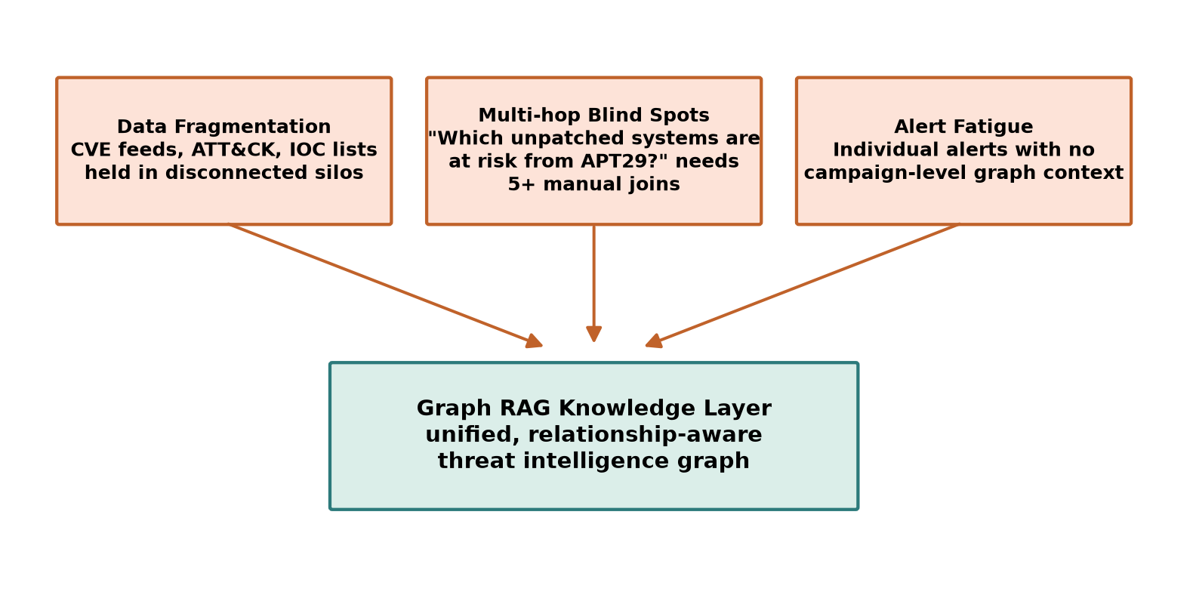
Figure 1.1 Compounding Challenges Facing SOC Analysts Today

1.4 OBJECTIVES
The primary aim of this project is to design and build a Graph RAG–powered cybersecurity threat intelligence platform that unifies public threat data into a single knowledge graph and exposes it through natural-language, multi-hop reasoning. These objectives are designed to address the limitations of siloed threat-intel tooling and flat-document RAG systems described above.

1.4.1 General Objective
To design and implement a Graph RAG framework, built on a Neo4j knowledge graph and a LangChain reasoning layer, capable of answering multi-hop cybersecurity questions with relationship-aware, evidence-grounded responses.

1.4.2 Specific Objectives

1.4.2.1 Data Ingestion and Normalization
❖ To ingest and normalize CVE, ATT&CK, CAPEC, CWE, OTX, CISA KEV, and EPSS data through idempotent, MERGE-based ETL pipelines.
❖ To deduplicate indicators of compromise and enforce Traffic Light Protocol (TLP) handling at ingestion time.
❖ To generate and store vector embeddings for all nodes carrying free-text descriptions.

1.4.2.2 Graph Schema and Relationship Modeling
❖ To define a property graph schema whose node and relationship types capture the real causal chain of a cyber attack — actor, technique, malware, CVE, and affected product.
❖ To bridge MITRE ATT&CK, CAPEC, and CWE through cross-reference relationships, enabling actor-to-technique-to-CVE-to-product traversal in a single query.

1.4.2.3 Graph RAG Engine Development
❖ To build a hybrid retrieval engine combining LLM-generated Cypher traversal with vector similarity search.
❖ To engineer a domain-tuned Cypher-generation prompt embedding the full graph schema.
❖ To benchmark the hybrid Graph RAG approach against flat-document RAG and traditional keyword correlation for multi-hop query accuracy.
Table 1.2 Comparative Capability of Threat-Intelligence Retrieval Approaches
Approach | Multi-hop Reasoning | Relationship Grounding | Remarks
Manual SIEM / keyword correlation | Poor | None (manual joins) | Fully dependent on analyst effort
Flat-document RAG (vector similarity only) | Weak | Implicit, prone to hallucination | Good for unstructured text lookup
Graph traversal only (Cypher, no LLM) | Strong | Explicit | Requires analyst to know Cypher
Graph RAG (proposed hybrid) | Strong | Explicit + semantic fallback | Natural language in, evidence-grounded answer out

1.4.2.4 Evaluation and Validation
❖ To evaluate Cypher-generation accuracy, retrieval precision, and answer groundedness against a curated set of analyst-style benchmark questions.
❖ To validate graph completeness and cross-source linkage (ATT&CK ↔ CAPEC ↔ CWE) after each ingestion run.

1.4.2.5 Web Application Overview
The platform delivers its intelligence through a role-aware web application built around:
❖ Dashboard Home: current KEV exposure, active threat-actor activity, and top-priority CVEs at a glance.
❖ Natural-Language Query Console: free-text questions answered with the underlying graph path, sources, and generated Cypher shown for transparency.
❖ Actor and CVE Explorer: drill-down profiles with TTP grids, ATT&CK heat-maps, and enrichment detail.
❖ Hunt Package Generator: downloadable, ATT&CK-mapped hunting packages for a chosen threat actor or campaign.

1.4.2.6 Deployment and Practical Use
Figure 1.2 traces the objective pipeline end to end, from multi-source ingestion through to the analyst-facing dashboard, showing how each objective above feeds the next.
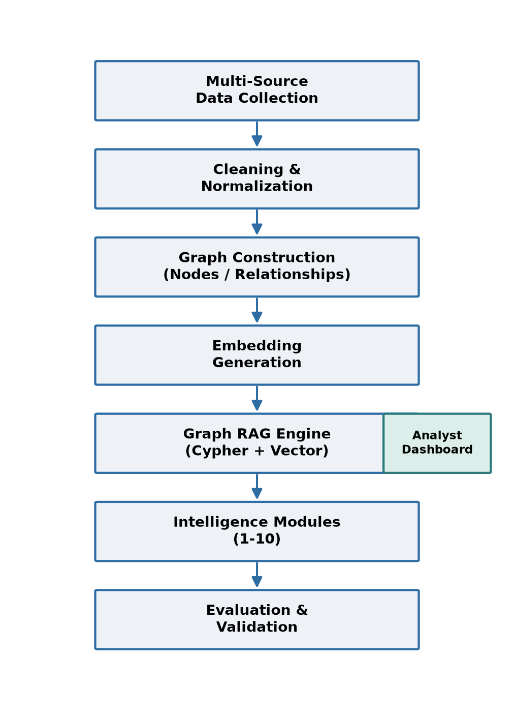
Figure 1.2 Proposed System Objective Pipeline

1.4.2.7 Expected Outcomes
❖ A single natural-language interface capable of multi-hop reasoning that flat-document RAG cannot perform.
❖ Faster analyst triage through relationship-aware, evidence-grounded answers instead of manual cross-referencing.
❖ A quantitative, defensible CVE prioritization signal (the ThreatPriority Score) that goes beyond raw CVSS.

1.5 IMPORTANCE OF GRAPH-BASED THREAT INTELLIGENCE
Representing threat intelligence as a graph rather than a collection of independent records is important because the value of the data lies almost entirely in its relationships, not in any single record read in isolation. A CVE's severity means little without knowing whether it is being actively exploited; a threat actor's profile means little without knowing which of the organisation's products fall inside their known TTP footprint.
Table 1.3 Importance of Graph RAG Threat Intelligence for Different Stakeholders
Stakeholder | Importance
SOC Analyst | Faster triage through relationship-aware context instead of manual pivoting
Threat Hunter | Hypothesis-driven queries grounded in actor TTP and IOC graph traversal
Vulnerability Manager | Prioritization beyond CVSS, using KEV status, EPSS, and actor/malware exploitation counts
Incident Responder | Graph-grounded playbooks and rapid actor-attribution scoring during active incidents
CISO / Executive | Concise, evidence-backed landscape summaries for risk-based investment decisions

By enabling evidence-based, relationship-aware decision-making, Graph RAG threat intelligence supports the broader goal of reducing dwell time and strengthening organisational resilience.

1.6 ROLE OF LLMS AND GRAPH RAG IN THREAT INTELLIGENCE
The complexity of cybersecurity threat data demands methods that can handle large-scale, heterogeneous, and constantly evolving information. Large Language Models alone hallucinate confidently when asked about specific, verifiable facts such as CVE identifiers or actor attribution; graph databases alone require Cypher fluency that most analysts do not have. Graph RAG combines the two:
❖ Natural-Language Access: Analysts ask questions in plain English; the LLM generates the underlying Cypher query.
❖ Relationship Grounding: Answers are derived from actual graph traversal, not from text similarity alone, which sharply reduces hallucination.
❖ Multi-hop Reasoning: A single query can traverse actor → technique → malware → CVE → product in one pass.
❖ Evidence and Provenance: Every answer can be returned alongside the graph path and the Cypher query used to generate it, so analysts can verify the reasoning.

1.7 SIGNIFICANCE
The significance of this project lies in its ability to provide real-world impact for security teams:
❖ SOC analysts gain a single conversational entry point into a threat landscape that previously existed only in fragments.
❖ Vulnerability managers can prioritize patching using a composite, actor-aware score rather than CVSS alone.
❖ Incident responders receive graph-grounded playbooks in the critical early minutes of an active incident.
❖ The organisation moves toward a proactive, intelligence-driven security posture rather than a reactive one.

1.8 SCOPE
The scope of this project includes:
❖ To ingest and unify public threat intelligence data (NVD, ATT&CK, CAPEC, CWE, OTX, CISA KEV, EPSS) into a single Neo4j knowledge graph.
❖ To design a graph schema whose relationships bridge ATT&CK, CAPEC, and CWE for multi-hop reasoning.
❖ To build a hybrid Graph RAG engine combining Cypher traversal and vector similarity retrieval.
❖ To deliver ten modular intelligence capabilities on top of the shared graph.
❖ To expose all capabilities through a documented REST API and an analyst-facing Streamlit UI.
❖ To restrict the platform to free, publicly available data sources — no commercial threat-intel licences are required.

1.9 LIMITATIONS OF EXISTING SYSTEMS
Despite the maturity of individual threat-intelligence feeds, existing workflows that consume them face several structural limitations that motivate this project:
❖ Existing SIEM and threat-intel platforms primarily rely on keyword and IOC matching, which cannot express multi-hop relationships between actors, techniques, and vulnerabilities.
❖ Most vulnerability-management tools score risk using CVSS alone, ignoring real-world exploitation evidence such as CISA KEV status or EPSS probability.
❖ Flat-document RAG systems retrieve semantically similar text but cannot guarantee that the relationships implied in an answer are actually grounded in verified data.
❖ Cross-referencing MITRE ATT&CK, CAPEC, and CWE today is a manual, spreadsheet-driven exercise with no live, queryable link between the three taxonomies.
❖ Existing systems provide static, single-source lookups without interactive, role-based visualization tailored to analysts, hunters, or executives.

1.10 OVERVIEW OF THE PROPOSED SYSTEM
The proposed CyberGraph Intelligence Platform overcomes these limitations by unifying threat intelligence into a single, relationship-rich knowledge graph and reasoning over it with a hybrid Graph RAG engine:
❖ Unifies NVD, MITRE ATT&CK, CAPEC, CWE, AlienVault OTX, CISA KEV, and EPSS into one Neo4j knowledge graph, refreshed on daily and hourly schedules.
❖ Bridges ATT&CK, CAPEC, and CWE through explicit cross-reference relationships, enabling true actor-to-product multi-hop traversal.
❖ Combines LLM-generated Cypher traversal with vector similarity search in a single hybrid retriever.
❖ Computes a composite ThreatPriority Score that folds CVSS, KEV status, EPSS probability, and actor/malware exploitation counts into one prioritization signal.
❖ Delivers ten intelligence modules through a FastAPI REST layer and a Streamlit analyst UI.
In summary, the fragmentation of public threat intelligence continues to slow down the very analysts it is meant to empower. By modelling that intelligence as a single interconnected graph and reasoning over it in natural language, this project aims to close the gap between raw threat data and the evidence-grounded, multi-hop answers that real security decisions require.

CHAPTER 2
LITERATURE REVIEW
This chapter reviews significant research in graph-based knowledge representation and Retrieval-Augmented Generation as applied to cybersecurity threat intelligence. The works surveyed span the foundational Graph RAG technique itself, knowledge-graph constructions purpose-built for cyber threat data, and LLM-driven systems that reason over MITRE ATT&CK and related taxonomies. Each subsection summarises the methodology, findings, and limitations of the reviewed work, and positions how the proposed CyberGraph platform builds upon it.

2.1 EXISTING RESEARCH

2.1.1 From Local to Global: A Graph RAG Approach to Query-Focused Summarization – Edge, D., Trinh, H., Cheng, N., Bradley, J., Chao, A., Mody, A., Truitt, S., Larson, J. (2024)
Edge et al. introduced GraphRAG at Microsoft Research, a technique that builds an LLM-derived knowledge graph from a document corpus — extracting entities and relationships, then clustering them into hierarchical community summaries — before answering a query by traversing that graph rather than retrieving isolated text chunks. Their evaluation showed GraphRAG substantially outperforming conventional vector-similarity RAG on query-focused summarization and multi-hop, “global sense-making” questions that require synthesising information scattered across many source documents. The work established the core architectural premise this project builds on — that structured graph traversal, not flat chunk retrieval, is what makes multi-hop reasoning reliable — but it was demonstrated on general narrative corpora rather than a cybersecurity-specific schema, and its LLM-constructed graph is not grounded in authoritative external taxonomies such as MITRE ATT&CK.

2.1.2 Cybersecurity Threat Hunting and Vulnerability Analysis Using a Neo4j Graph Database of Open Source Intelligence – Pelofske, E., Liebrock, L. M., Urias, V. (2023)
Pelofske et al. constructed a Neo4j graph database that fuses open-source vulnerability and threat intelligence feeds, demonstrating how graph traversal and visualization can support threat hunting and vulnerability analysis workflows that flat spreadsheets and relational databases handle poorly. Their work validated Neo4j as a practical, production-ready substrate for cybersecurity graph modelling and showed measurable gains in analyst efficiency when relationships between assets, vulnerabilities, and intelligence indicators are made explicit and queryable. The study, however, focused on graph construction and traversal rather than natural-language access — analysts still needed to write Cypher queries directly, which is the exact usability gap Graph RAG is designed to close.

2.1.3 CyKG-RAG: Towards Knowledge-Graph Enhanced Retrieval Augmented Generation for Cybersecurity – Kurniawan, K., Kiesling, E., Ekelhart, A. (2024)
Presented at the RAGE-KG workshop of ISWC 2024, CyKG-RAG integrates cybersecurity knowledge graphs — built from sources including MITRE ATT&CK — with a Retrieval-Augmented Generation pipeline, contextualising local security events with external threat intelligence to improve detection and analysis accuracy. The authors demonstrated that grounding retrieval in a structured knowledge graph measurably improves the contextual relevance of LLM-generated security analyses compared to unstructured retrieval. The framework, however, is oriented toward event-contextualisation for detection rather than the broader set of analyst workflows — actor profiling, attack-path mapping, risk scoring, and incident response — that a full intelligence platform needs to cover.

2.1.4 LLM-Powered Threat Intelligence: A Retrieval-Augmented Generation Approach for Cyber Attack Investigation – Alhuzali, A. (2025)
Alhuzali proposed RAGIntel, a RAG-based LLM system that retrieves structured threat intelligence from MITRE ATT&CK using a hybrid retrieval algorithm with re-ranking and compression, aimed at reducing hallucination and stale-knowledge errors during cyber-attack investigation. The system reported improved precision in linking investigation queries to the correct ATT&CK techniques compared to a plain LLM baseline, reinforcing the value of grounding retrieval in an authoritative taxonomy. The work is centred on ATT&CK alone, however, and does not extend the same grounding to CVE, CWE/CAPEC, or live indicator-of-compromise data — the cross-source bridge this project specifically targets.

2.1.5 CTI-Thinker: An LLM-Driven System for CTI Knowledge Graph Construction and Attack Reasoning – Yang, X., Zhong, R., Chen, Y., Peng, G., et al. (2026)
Published in the Cybersecurity journal, CTI-Thinker integrates a GraphRAG-based reasoning mechanism with in-context learning and LoRA-based fine-tuning to perform structured extraction of threat entities and relations, semantic alignment against MITRE ATT&CK, knowledge-graph fusion, and tactic/technique-level attack-intent inference from raw CTI reports. Experimental results showed the system could accurately construct a CTI knowledge graph and infer attack intent, supporting intelligent reasoning over unstructured intelligence reports. The system's reasoning is anchored specifically on report-to-ATT&CK mapping; it does not incorporate CVE-level exploitation evidence (such as CISA KEV or EPSS) into its prioritisation logic, which limits its direct use for vulnerability-management decisions.

2.1.6 TITAN: Graph-Executable Reasoning for Cyber Threat Intelligence – Simoni, M., Fontana, A., Saracino, A., Mori, P. (2025)
Simoni et al. proposed TITAN, a framework connecting natural-language threat-intelligence queries to executable reasoning over a structured knowledge graph via a path-planner model that predicts logical relation chains from text, paired with a graph executor that traverses a purpose-built threat ontology to retrieve factual answers with supporting evidence. TITAN's design closely parallels the dual-chain retrieval strategy adopted in this project, confirming that separating “what relationships to traverse” from “how to execute the traversal” is an effective pattern for graph-grounded cyber threat reasoning. The published ontology, however, is narrower in entity coverage than the seven-source schema proposed here, and does not natively incorporate a vulnerability-prioritisation score.

2.2 KEY OBSERVATIONS FROM EXISTING RESEARCH

2.2.1 Knowledge-Graph Construction Approaches
Across the reviewed work, knowledge graphs for cybersecurity are built either by parsing structured authoritative sources directly (ATT&CK STIX bundles, CVE/CPE feeds) or by using an LLM to extract entities and relations from unstructured CTI reports. Structured-source construction yields higher precision and MERGE-safe idempotency; LLM-based extraction offers broader coverage of narrative intelligence but requires additional validation to avoid propagating extraction errors into the graph.

2.2.2 Retrieval Strategies
Reviewed systems increasingly favour hybrid retrieval — combining graph traversal for structured, relationship-based questions with vector similarity search for fuzzy or semantic ones — over either mode alone. Graph traversal alone requires Cypher fluency from the end user; vector similarity alone cannot reliably express multi-hop chains, making the hybrid combination the consistent design choice across recent work.

2.2.3 LLM-Driven Reasoning and Attack-Chain Inference
Several works (CTI-Thinker, TITAN) demonstrate that an LLM can be steered to infer attack-chain structure — the ordering of tactics and techniques in a campaign — when its reasoning is constrained to traverse a verified graph rather than free-generate from parametric memory. This constraint is what distinguishes graph-grounded reasoning from a standalone LLM's tendency to hallucinate plausible-sounding but unverified relationships.

2.2.4 Incorporation of Standardized Taxonomies
MITRE ATT&CK is the near-universal anchor taxonomy across the reviewed systems, reflecting its role as the industry's common vocabulary for adversary behaviour. Fewer systems extend that anchor to CAPEC and CWE, and fewer still fold in live exploitation-evidence feeds such as CISA KEV or EPSS — leaving a gap between technique-level intelligence and vulnerability-level prioritisation that this project specifically addresses.

2.2.5 Decision Support and Analyst-Facing Applications
Most reviewed research concludes at the retrieval or knowledge-graph-construction stage, with limited attention to how the resulting intelligence is delivered to SOC analysts, threat hunters, or executives in daily practice. Dashboards, hunt-package generation, and role-based views remain comparatively under-explored in the academic literature, despite being decisive for real-world adoption.

2.3 GAPS IN EXISTING KNOWLEDGE
Although recent research firmly establishes that graph-grounded retrieval outperforms flat-document RAG for cybersecurity question answering, several gaps remain. First, most systems anchor their graph to a single taxonomy — typically MITRE ATT&CK — without bridging it to CAPEC and CWE, which prevents the actor-to-root-cause-weakness traversal that connects adversary behaviour back to exploitable software defects. Second, exploitation-evidence signals such as the CISA KEV catalogue and the EPSS exploitation-probability score are rarely integrated into the same graph as ATT&CK and CVE data, so existing systems cannot compute a single, defensible vulnerability-prioritisation score that accounts for both severity and real-world exploitation. Third, published work concentrates on the retrieval engine itself, with comparatively little treatment of the downstream intelligence modules — attack-path mapping, IOC pivoting, hunt-package generation, incident-response playbooks, and executive reporting — that translate a graph-grounded answer into an actionable analyst workflow. Finally, few systems are built exclusively on free, publicly available data, which limits reproducibility and adoption outside organisations with commercial threat-intel budgets.

2.4 VALUE ADDITION OF THE PROPOSED SYSTEM
The proposed CyberGraph Intelligence Platform directly addresses these gaps. It bridges MITRE ATT&CK, CAPEC, and CWE through explicit cross-reference relationships, enabling true actor-to-technique-to-weakness traversal rather than treating each taxonomy in isolation. It integrates CISA KEV status and EPSS exploitation probability directly into the CVE nodes of the same graph used for actor and technique reasoning, enabling a composite ThreatPriority Score that existing single-taxonomy systems cannot compute. It extends beyond a retrieval engine to ten analyst-facing modules — actor intelligence, vulnerability enrichment, attack-path analysis, IOC correlation, threat hunting, risk scoring, incident response, and executive reporting — delivered through a documented REST API and a role-aware analyst UI. Finally, the entire platform is built on free, publicly available sources, so the approach and its findings are fully reproducible without dependence on commercial threat-intelligence licences.

CHAPTER 3
METHODOLOGY
This chapter describes the architecture, data sources, graph schema, retrieval design, and evaluation approach proposed for the CyberGraph Intelligence Platform. The design follows a modular, layered methodology covering every stage from raw threat-intelligence ingestion through to analyst-facing delivery.

3.1 SYSTEM OVERVIEW
The platform is built around a single Neo4j knowledge graph that unifies seven public threat-intelligence sources, reasoned over by a hybrid Graph RAG engine, and delivered through ten modular intelligence capabilities. The proposed methodology has five high-level components:
❖ Data ingestion and normalization
❖ Graph construction and embedding generation
❖ Graph RAG engine development (Cypher chain + vector retriever)
❖ Intelligence module development (Modules 1–10)
❖ Evaluation, delivery, and visualization
Data flows sequentially from ingestion and graph construction, through the reasoning layer, to the module and delivery layers, while each layer remains independently testable and independently scalable. This structure allows new data sources, new modules, or a different LLM backend to be introduced without redesigning the rest of the system.

3.2 PROBLEM-SOLVING APPROACH
The proposed solution follows a graph-first, evidence-grounded reasoning approach. The methodology begins with ingesting multi-source threat intelligence into a unified schema, followed by embedding generation to support semantic retrieval. A hybrid Graph RAG engine — combining LLM-generated Cypher traversal with vector similarity search — is then used to answer natural-language questions with relationship-grounded evidence. Finally, the resulting intelligence is surfaced through ten modular capabilities and evaluated against a benchmark set of analyst-style questions.

3.3 TECHNOLOGIES USED
This project employs a combination of graph database, LLM orchestration, data-engineering, and web delivery technologies, chosen to keep the platform reproducible on entirely free and open data and tooling.

3.3.1 Programming Language
❖ Python is used as the primary language across ingestion, graph construction, the RAG engine, and the API layer, owing to its mature ecosystem for both data engineering and LLM orchestration.

3.3.2 Graph Database and Query Layer
❖ Neo4j 5.x (Community Edition / AuraDB Free), with the Graph Data Science (GDS) and APOC plugins enabled, provides native Cypher traversal, shortest-path algorithms, and a built-in vector index.

3.3.3 RAG Orchestration Framework
❖ LangChain (with langchain-neo4j) supplies GraphCypherQAChain for LLM-to-Cypher translation and the Neo4jVector retriever for embedding similarity search, orchestrated behind a single hybrid retriever interface.

3.3.4 LLM Backend
❖ The LLM backend is pluggable — Claude 3.5 Sonnet or GPT-4o for cloud deployments, or a local Ollama model (Mistral / Llama 3) for fully air-gapped deployments — selected via configuration rather than hard-coded into the pipeline.

3.3.5 Embedding Model
❖ sentence-transformers/all-MiniLM-L6-v2 is used by default for local, no-cost embedding generation across all nodes carrying descriptive text.

3.3.6 Task Queue and Scheduling
❖ Celery with a Redis broker schedules the initial bulk ingestion and the recurring incremental refresh jobs (daily NVD/KEV/EPSS pulls, hourly OTX pulses).

3.3.7 Web Application and API Technologies
❖ FastAPI serves all module endpoints with automatic OpenAPI documentation; Streamlit provides the analyst-facing UI, including graph visualisation via streamlit-agraph and pyvis.

3.3.8 Data Ingestion Libraries
❖ mitreattack-python (official MITRE ATT&CK SDK), OTXv2 (AlienVault OTX SDK), stix2 (STIX bundle parsing), and lxml (CAPEC/CWE XML parsing) handle source-specific ingestion.

3.3.9 Development Environment and Version Control
❖ Jupyter Notebook supports exploratory schema and query development; Git and GitHub track source control and collaboration; Docker Compose orchestrates Neo4j, Redis, the API, the worker, the scheduler, and the UI as a single reproducible stack.

3.3.10 Evaluation Metrics and Tools
❖ Cypher-generation accuracy, retrieval precision/recall, and answer-groundedness are measured against a curated benchmark question set; pytest drives unit and integration testing of all API endpoints.

3.4 SYSTEM ARCHITECTURE
The proposed system architecture is a modular, six-layer design that seamlessly integrates data acquisition, graph construction, hybrid reasoning, ten intelligence modules, and delivery, supporting scheduled refresh of live feeds and continuous graph growth without redesign.
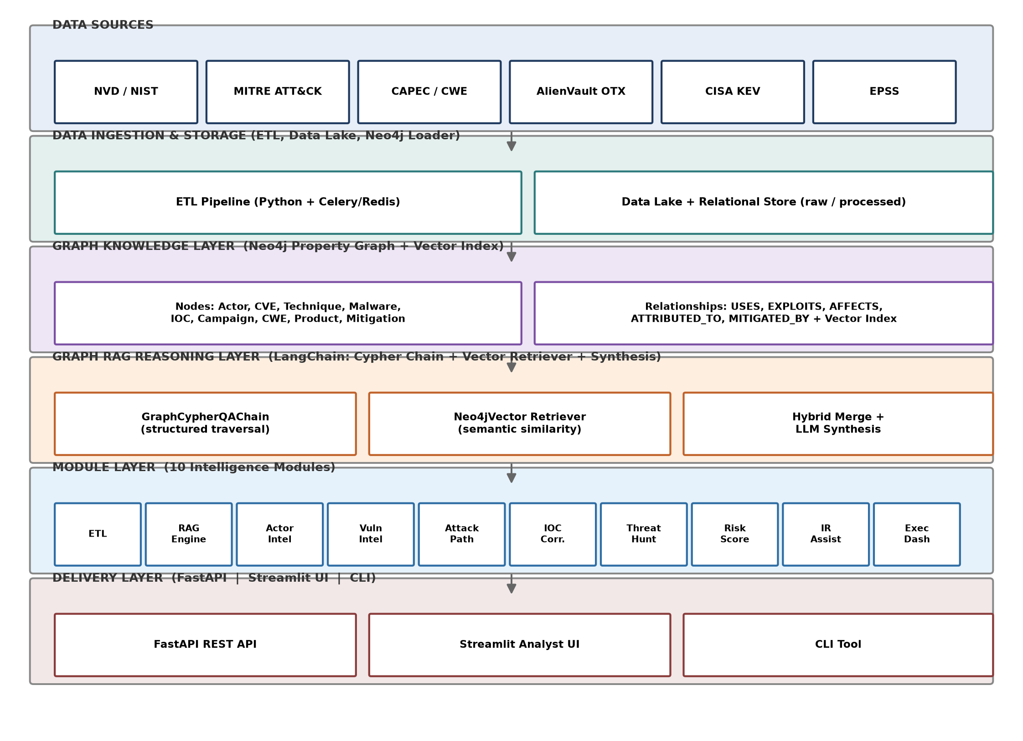
Figure 3.1 End-to-End System Architecture of the CyberGraph Intelligence Platform

3.4.1 Data Sources Layer
Seven public sources feed the platform: NVD/NIST (CVE, CVSS, CPE), MITRE ATT&CK (tactics, techniques, groups, software, mitigations), CAPEC and CWE (attack patterns and weaknesses), AlienVault OTX (IOC pulses), CISA KEV (confirmed exploitation), and EPSS (exploitation probability).

3.4.2 Data Ingestion and Storage Layer
An ETL pipeline (Python + Celery/Redis) extracts, cleans, and normalizes raw feed data before loading it into Neo4j using idempotent MERGE operations, so that any feed can be re-run safely without creating duplicate nodes or relationships. Raw and intermediate data is staged in a data lake / relational store ahead of graph loading.

3.4.3 Graph Knowledge Layer
The Neo4j property graph stores all typed nodes and relationships, alongside a native vector index over node embeddings, forming the single source of truth queried by every downstream module.

3.4.4 Graph RAG Reasoning Layer
A LangChain-orchestrated reasoning layer accepts natural-language questions and routes them through a GraphCypherQAChain for structured traversal, a Neo4jVector retriever for semantic similarity, and a hybrid merge stage that combines both before LLM synthesis. Section 3.9 details this layer.

3.4.5 Module Layer
Ten intelligence modules — ETL, the RAG engine itself, actor intelligence, vulnerability intelligence, attack-path analysis, IOC correlation, threat hunting, risk scoring, incident-response assistance, and the executive dashboard — sit on top of the shared graph, each independently callable through the API layer.

3.4.6 Delivery Layer
A FastAPI REST API exposes every module; a Streamlit analyst UI provides interactive, role-based views; a lightweight CLI tool supports scripted or automated querying.

3.4.7 System Integration and Workflow
Data flows top-down through the architecture: sources are ingested into the data lake and graph, the graph is enriched with embeddings, the reasoning layer answers queries by traversing that graph, the module layer packages those answers into analyst-relevant capabilities, and the delivery layer exposes the result via API, UI, and CLI. Continuous re-ingestion (daily/hourly, per source) keeps the graph — and therefore every downstream module — current without manual intervention.

3.4.8 Non-Functional Considerations
❖ Scalability: the layered, Docker Compose–based design allows new data sources or modules to be added without restructuring existing components.
❖ Performance: scheduled incremental refresh (rather than full reloads) keeps query latency low as the graph grows.
❖ Reliability: idempotent MERGE-based ingestion guarantees safe re-runs; TLP enforcement prevents restricted indicators from leaking into shared responses.
❖ Maintainability: each module is a self-contained file with its own API router, so it can be modified independently of the reasoning layer.

3.5 GRAPH KNOWLEDGE SCHEMA
The graph schema is the single most important design decision in the platform: it is the bridge between MITRE ATT&CK, CAPEC, and CWE that enables true multi-hop actor-to-technique-to-CVE-to-product reasoning, which is the platform's core value proposition.
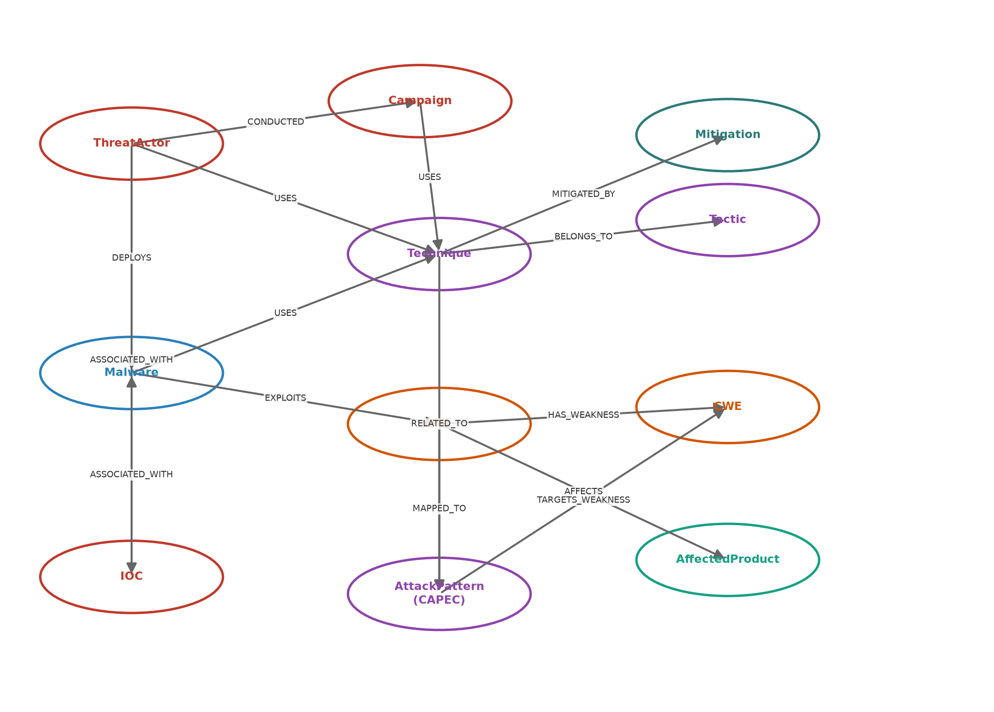
Figure 3.2 Graph Knowledge Schema — Node Types and Relationships
Table 3.1 Core Node Types in the Graph Knowledge Schema
Node Label | Key Properties | Populated From
ThreatActor | id, name, aliases, motivation, sophistication | MITRE ATT&CK Groups
Campaign | id, name, objective, first_seen, last_seen | MITRE ATT&CK, OTX
Technique / Tactic | id, name, description, detection | MITRE ATT&CK
Malware | id, name, type, platforms, aliases | MITRE ATT&CK Software
CVE | id, cvss_v3_score, severity, is_kev, epss_score | NVD, CISA KEV, EPSS
CWE | id, name, abstraction | MITRE CWE
AffectedProduct | cpe, vendor, product, version | NVD (CPE)
AttackPattern | id, name, likelihood, severity | MITRE CAPEC
Mitigation | id, name, description | MITRE ATT&CK
IOC | value, type, confidence, tlp | AlienVault OTX

Table 3.2 Core Relationship Types in the Graph Knowledge Schema
Relationship | Direction | Purpose
USES | ThreatActor / Campaign / Malware → Technique | Links actors and tools to observed behaviour
DEPLOYS | ThreatActor → Malware | Links actors to the tools they operate
EXPLOITS | Malware → CVE | Links malware to the vulnerabilities it weaponises
AFFECTS | CVE → AffectedProduct | Links a vulnerability to exposed products
HAS_WEAKNESS | CVE → CWE | Links a vulnerability to its root-cause weakness
RELATED_TO / MAPPED_TO | Technique ↔ AttackPattern; CVE → AttackPattern | Bridges ATT&CK ↔ CAPEC ↔ CWE
MITIGATED_BY | Technique → Mitigation | Links a technique to its defensive countermeasure
ASSOCIATED_WITH | IOC ↔ ThreatActor / Campaign / Malware | Links observed indicators to attribution

3.6 DATA COLLECTION
Data is collected from the seven public sources introduced in Section 3.4.1, using dedicated connectors per source and a common ETL pipeline for normalization.
Table 3.3 Dataset Description
Data Type | Description | Refresh Cadence | Purpose
CVE / CVSS / CPE | Vulnerability records and affected products | Daily | Vulnerability intelligence
ATT&CK Techniques / Groups | Adversary tactics, techniques, actors, software | Monthly | Actor and technique intelligence
CAPEC / CWE | Attack patterns and root-cause weaknesses | Quarterly | Weakness bridging
OTX Pulses / IOCs | Indicators of compromise and campaign context | Hourly | IOC correlation
CISA KEV | Confirmed in-the-wild exploited CVEs | Daily | Prioritization signal
EPSS | Exploit-probability score per CVE | Daily | Prioritization signal

3.7 DATA PREPROCESSING
Preprocessing ensures the graph remains consistent, deduplicated, and safe to re-ingest. Key steps include:
❖ CPE string normalization into the structured AffectedProduct schema.
❖ STIX 2.1 bundle parsing for MITRE ATT&CK objects.
❖ IOC deduplication across overlapping OTX pulses, with Traffic Light Protocol (TLP) enforced at ingestion — TLP:RED indicators are never persisted.
❖ Idempotent MERGE (never CREATE) for every node and relationship write, so incremental refresh jobs can be safely re-run without producing duplicates.
❖ Cross-reference validation between ATT&CK, CAPEC, and CWE after each load, to confirm the bridging relationships that enable multi-hop traversal remain intact.

3.8 EMBEDDING GENERATION
On first ingest, text embeddings are generated for every node carrying a free-text description field (ThreatActor, Technique, Malware, CVE, AttackPattern) using the local, no-cost sentence-transformers/all-MiniLM-L6-v2 model, and stored in a Neo4j vector index. This index is what powers the semantic-similarity half of the hybrid retriever described in Section 3.9.

3.9 GRAPH RAG ENGINE AND EXPERIMENTAL SETUP
The Graph RAG engine is the reasoning core of the platform. It combines two complementary retrieval modes, merged before final answer synthesis, so that both structured and fuzzy queries are answered correctly.
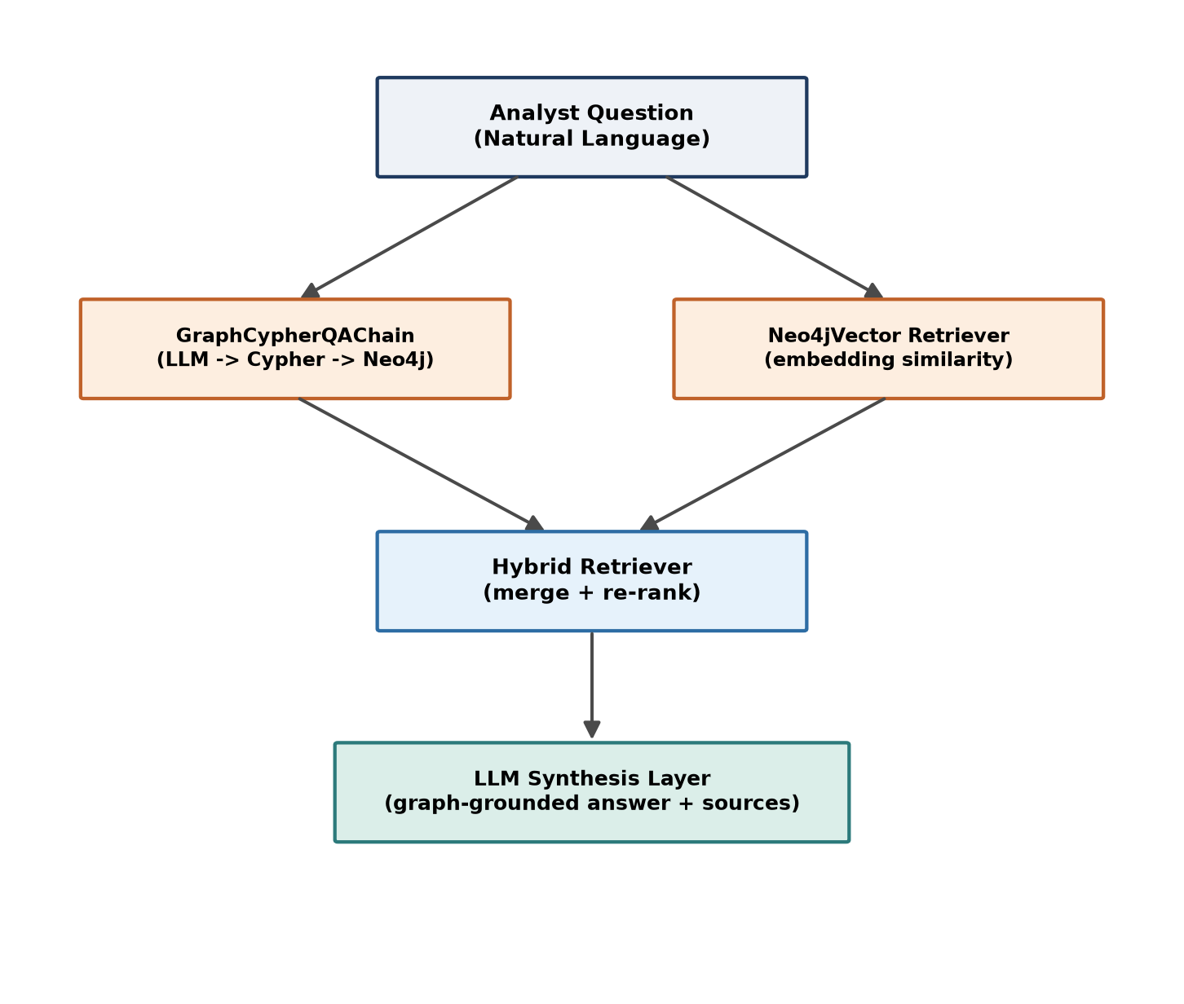
Figure 3.3 Hybrid Graph RAG Retrieval Architecture

3.9.1 GraphCypherQAChain (Structured Retrieval)
A domain-tuned prompt embeds the full graph schema and instructs the LLM to translate a natural-language question into a Cypher query, chaining relationships explicitly for multi-hop questions (for example, ThreatActor → USES → Technique → (malware) → EXPLOITS → CVE → AFFECTS → AffectedProduct).

3.9.2 Neo4jVector Retriever (Semantic Retrieval)
For fuzzy or semantic queries — such as “techniques similar to phishing” — the Neo4jVector retriever performs cosine-similarity search over the embedding index built in Section 3.8.

3.9.3 Hybrid Merge and LLM Synthesis
Results from both chains are merged and re-ranked before being passed to the LLM synthesis layer, which produces a final answer accompanied by the graph path traversed, the Cypher query used, and the originating data sources — giving the analyst a verifiable evidence trail rather than an opaque answer.

3.10 INTELLIGENCE MODULE DESIGN
Ten modules sit on top of the shared graph, each independently callable through the API layer.
Table 3.4 The Ten Intelligence Modules
# | Module | Core Capability
1 | Data Ingestion & ETL | Idempotent, scheduled ingestion from all seven sources
2 | Graph RAG Query Engine | Hybrid Cypher + vector retrieval with LLM synthesis
3 | Threat Actor Intelligence | Actor dossiers, TTP profiles, side-by-side comparison
4 | Vulnerability Intelligence | CVE enrichment and ThreatPriority Score computation
5 | Attack Path Analyzer | Kill-chain mapping and detection-gap analysis
6 | IOC Correlation Engine | IOC enrichment, pivoting, and bulk screening
7 | Threat Hunting Workbench | Hypothesis-to-Sigma hunt package generation
8 | Risk Scoring Engine | Asset, sector, and detection-coverage-gap scoring
9 | Incident Response Assistant | Graph-grounded IR playbooks and attribution scoring
10 | Executive Intelligence Dashboard | Landscape summaries and CISO-facing metrics

Module 4 computes a composite ThreatPriority Score (TPS) that folds CVSS, CISA KEV status, EPSS percentile, and the number of known threat actors/malware exploiting a CVE into a single, 0–100 prioritization signal — a more actionable measure than raw CVSS alone, and the direct counterpart to the gap identified in Section 2.3.

3.11 EVALUATION PLAN

3.11.1 Benchmark Query Set
A curated set of analyst-style natural-language questions — spanning actor profiling, CVE prioritisation, attack-path mapping, IOC pivoting, and defensive-gap analysis — will be used to evaluate the Graph RAG engine, with each question paired against a manually verified expected graph path and answer.

3.11.2 Evaluation Metrics
❖ Cypher-Generation Accuracy: proportion of benchmark questions for which the LLM-generated Cypher query returns the manually verified correct result set.
❖ Retrieval Precision / Recall: relevance of nodes and relationships returned by the hybrid retriever against the expected graph path.
❖ Answer Groundedness: proportion of claims in the synthesized answer that are directly traceable to a returned graph path, used to quantify hallucination reduction relative to a flat-document RAG baseline.
❖ Graph Completeness: coverage of cross-reference relationships (ATT&CK ↔ CAPEC ↔ CWE) verified after each ingestion run.

3.12 OUTPUT GENERATION AND VISUALIZATION

3.12.1 Web-Based Dashboard
The Streamlit dashboard surfaces current KEV exposure, active threat-actor activity for the organisation's sector, and the Top-10 CVEs by ThreatPriority Score.

3.12.2 Interactive Visualizations
Graph visualisations (via pyvis / streamlit-agraph) let an analyst pivot visually from an IOC or actor node outward through its connected campaigns, malware, and CVEs.

3.12.3 Decision-Support Features
Scenario views (such as “what if we deploy Sysmon coverage for these techniques?”) and role-based access ensure the right depth of detail reaches analysts, hunters, and executives respectively.

3.12.4 Usability and Interpretability
Every synthesized answer is paired with its underlying Cypher query and graph path, translating complex multi-hop reasoning into a form a non-technical stakeholder can still audit and trust.

3.13 EXISTING SYSTEM AND PROPOSED WORK

3.13.1 Existing System
Existing threat-intelligence workflows rely on independent, single-source tools: a vulnerability scanner reports CVSS scores in isolation, a SIEM correlates IOCs by keyword or hash match, and ATT&CK mapping is typically maintained as a manually updated spreadsheet. None of these tools share a common relational substrate, so answering a genuinely multi-hop question requires an analyst to manually bridge several systems by hand for every investigation.

3.13.2 Proposed Work
The proposed CyberGraph platform replaces this fragmented tooling with a single, continuously refreshed knowledge graph and a hybrid Graph RAG engine capable of answering the same multi-hop questions in natural language, with the underlying graph path shown as evidence.
Table 3.5 Existing System vs Proposed Work
Factor | Existing System | Proposed Work
Data Sources | Independent, single-source tools (scanner, SIEM, spreadsheet) | Unified graph across 7 sources: NVD, ATT&CK, CAPEC, CWE, OTX, CISA KEV, EPSS
Query Interface | Keyword search / manual Cypher / spreadsheet lookup | Natural language, answered via hybrid Cypher + vector retrieval
Multi-hop Reasoning | Manual, one relationship at a time | Automatic, multi-hop traversal in a single query
Vulnerability Prioritization | Raw CVSS score only | Composite ThreatPriority Score (CVSS + KEV + EPSS + actor/malware exploitation)
Delivery | Disconnected tools, no shared UI | Unified REST API + role-based Streamlit dashboard

In summary, the comparative analysis shows the proposed Graph RAG framework directly overcomes the single-source, manual-correlation limitations of existing threat-intelligence tooling, providing a single, relationship-aware, natural-language interface across the entire public threat landscape.

3.14 PHASED BUILD PLAN
The implementation is planned across a six-week schedule, sequencing graph schema and bulk ingestion first, then live feeds and embeddings, then the Graph RAG engine, then the ten modules, then the UI, and finally hardening and documentation.
Table 3.6 Six-Week Phased Build Plan
Week | Focus | Key Deliverable
1 | Graph schema definition and bulk ingestion (ATT&CK, NVD, CWE, CAPEC) | Populated Neo4j graph, ~50k+ nodes
2 | Live feeds (OTX, CISA KEV, EPSS) and embedding generation | Scheduled refresh + working vector search
3 | Graph RAG engine and Modules 1–5 | Natural-language queries answered via API/CLI
4 | Modules 6–10 (hunting, risk, IR, dashboard) | All 10 modules exposed via API
5 | Streamlit analyst UI | Functional UI across all major analyst workflows
6 | Hardening, testing, documentation | Documented, demo-ready platform via docker compose up

CHAPTER 4
CONCLUSION

4.1 Summary of the Work
This Phase-I report has presented the design of the CyberGraph Intelligence Platform, a Graph Retrieval-Augmented Generation system that unifies seven free, publicly available threat-intelligence sources — NVD, MITRE ATT&CK, CAPEC, CWE, AlienVault OTX, CISA KEV, and EPSS — into a single Neo4j knowledge graph, and reasons over that graph through a hybrid retrieval engine combining LLM-generated Cypher traversal with vector similarity search. The report has motivated the design against the concrete limitations of current SOC workflows — data fragmentation, multi-hop blind spots, and CVSS-only vulnerability prioritisation — reviewed the closely related research on Graph RAG and cybersecurity knowledge graphs, and specified the schema, architecture, module set, evaluation plan, and phased build schedule needed to implement it.

4.2 Key Contributions
❖ A graph schema that explicitly bridges MITRE ATT&CK, CAPEC, and CWE, enabling actor-to-technique-to-weakness-to-product traversal in a single query rather than three separate lookups.
❖ A hybrid Graph RAG retrieval design that pairs structured Cypher traversal with semantic vector search, addressing the multi-hop reasoning gap identified in flat-document RAG systems.
❖ A composite ThreatPriority Score formulation that folds CVSS, CISA KEV status, EPSS exploitation probability, and known actor/malware exploitation counts into a single, defensible prioritisation signal.
❖ A ten-module intelligence design spanning actor profiling, vulnerability enrichment, attack-path mapping, IOC correlation, threat hunting, risk scoring, incident response, and executive reporting, all served from the same underlying graph.
❖ A phased, six-week build plan sequencing schema and bulk ingestion, live feeds and embeddings, the Graph RAG engine, the ten modules, the analyst UI, and final hardening.

4.3 Alignment with Objectives
The design presented in this report directly addresses each objective set out in Chapter 1: the data-ingestion and graph-construction objective is met by the idempotent, MERGE-based ETL design of Section 3.4.2; the schema and relationship-modelling objective is met by the ATT&CK–CAPEC–CWE bridge of Section 3.5; the Graph RAG engine objective is met by the hybrid retriever of Section 3.9; and the evaluation objective is met by the benchmark query set and metrics defined in Section 3.11. Empirical validation of these design choices — Cypher-generation accuracy, retrieval precision, and answer groundedness measured against the benchmark set — is deferred to the implementation and evaluation carried out in Phase II.

4.4 Limitations of the Current Phase
❖ As a Phase-I design report, no implementation or empirical evaluation has yet been carried out; the schema, architecture, and evaluation plan described here are proposed designs to be built and measured in Phase II.
❖ The platform's data is limited to free, public sources; sector-specific ISAC feeds and commercial threat-intel platforms are intentionally out of scope to keep the system fully reproducible.
❖ LLM-generated Cypher queries can still be incorrect on edge-case phrasing; prompt refinement and query validation are planned as part of Phase II hardening.

4.5 Future Enhancements
❖ Implement and empirically evaluate the full six-week build plan of Section 3.14, including the benchmark-driven evaluation defined in Section 3.11.
❖ Extend live-feed integration to STIX/TAXII-based ISAC feeds for sector-specific intelligence.
❖ Add a Sigma-rule generator that auto-produces detection rules from ATT&CK technique and data-source graph relationships.
❖ Enrich AffectedProduct nodes with real-world exposure data (for example, via Shodan) to sharpen the ThreatPriority Score with internet-exposure context.
❖ Fine-tune a smaller, open-source model specifically on cybersecurity graph-reasoning tasks to reduce dependence on proprietary LLM APIs for fully air-gapped deployments.
With continued refinement through Phase II, the proposed CyberGraph Intelligence Platform has the potential to meaningfully shorten investigation time, surface risk that single-source correlation would miss, and give security teams a single, evidence-grounded, conversational entry point into a threat landscape that today exists only in fragments.

REFERENCES
[1] D. Edge, H. Trinh, N. Cheng, J. Bradley, A. Chao, A. Mody, S. Truitt, and J. Larson, “From local to global: A graph RAG approach to query-focused summarization,” arXiv preprint arXiv:2404.16130, Microsoft Research, 2024.
[2] E. Pelofske, L. M. Liebrock, and V. Urias, “Cybersecurity threat hunting and vulnerability analysis using a Neo4j graph database of open source intelligence,” arXiv preprint arXiv:2301.12013, 2023.
[3] K. Kurniawan, E. Kiesling, and A. Ekelhart, “CyKG-RAG: Towards knowledge-graph enhanced retrieval augmented generation for cybersecurity,” in Proc. RAGE-KG Workshop, Int. Semantic Web Conf. (ISWC), CEUR-WS, vol. 3950, 2024.
[4] A. Alhuzali, “LLM-powered threat intelligence: A retrieval-augmented generation approach for cyber attack investigation,” PeerJ Computer Science, vol. 11, p. e3371, 2025.
[5] X. Yang, R. Zhong, Y. Chen, G. Peng, D. Yao, C. Chen, C. Wang, D. Zhang, Y. Zhou, and Z. Yang, “CTI-Thinker: An LLM-driven system for CTI knowledge graph construction and attack reasoning,” Cybersecurity, vol. 9, no. 1, art. 106, 2026.
[6] M. Simoni, A. Fontana, A. Saracino, and P. Mori, “TITAN: Graph-executable reasoning for cyber threat intelligence,” arXiv preprint arXiv:2510.14670, 2025.
[7] MITRE Corporation, “MITRE ATT&CK®,” attack.mitre.org, 2024.
[8] National Institute of Standards and Technology (NIST), “National Vulnerability Database (NVD),” nvd.nist.gov, 2024.
[9] Cybersecurity and Infrastructure Security Agency (CISA), “Known Exploited Vulnerabilities (KEV) Catalog,” cisa.gov/known-exploited-vulnerabilities-catalog, 2024.
[10] FIRST.org, “Exploit Prediction Scoring System (EPSS),” first.org/epss, 2024.
[11] MITRE Corporation, “Common Attack Pattern Enumeration and Classification (CAPEC),” capec.mitre.org, 2024.
[12] MITRE Corporation, “Common Weakness Enumeration (CWE),” cwe.mitre.org, 2024.
[13] N. Reimers and I. Gurevych, “Sentence-BERT: Sentence embeddings using Siamese BERT-networks,” in Proc. Conf. Empirical Methods in Natural Language Processing (EMNLP-IJCNLP), 2019, pp. 3982–3992.
[14] Neo4j, Inc., “Neo4j Graph Data Science Library Documentation,” neo4j.com/docs/graph-data-science, 2024.
[15] LangChain, “GraphCypherQAChain and Neo4jVector — LangChain Documentation,” python.langchain.com, 2024.

